Project Design Phase-II
Technology Stack (Architecture & Stack)
Date | 14 October 2026
Team ID
Project Name | Automated Network Request Management System
Maximum Marks | 4 Marks

Technical Architecture:
The Deliverable includes the architectural diagram below and the information as per Table 1 & Table 2:
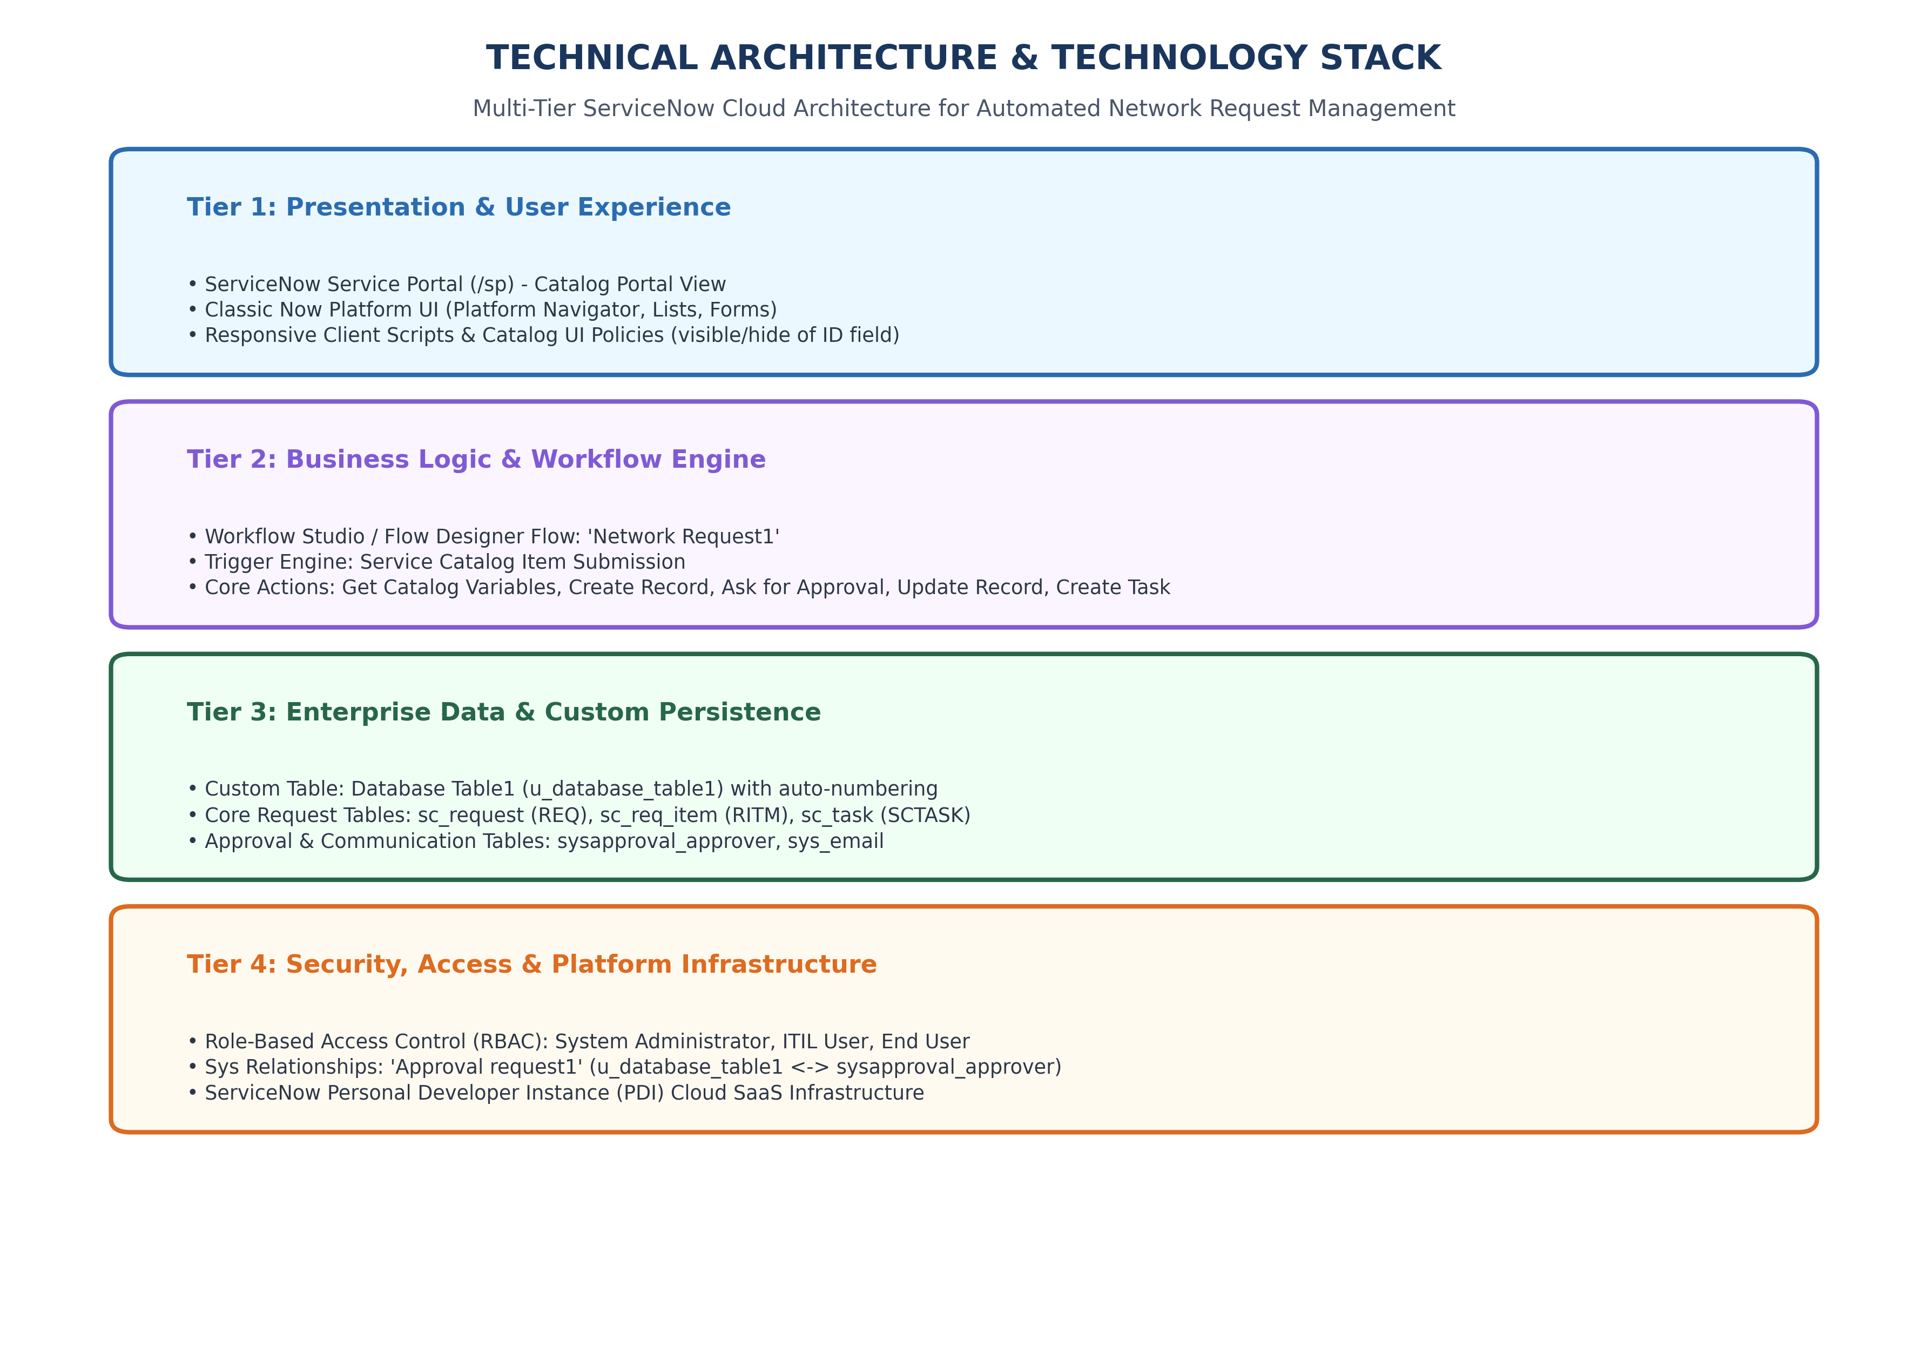
Figure 2.4: Multi-Tier ServiceNow Technical Architecture
Table-1 : Components & Technologies:
S.No | Component | Description | Technology
1 | User Interface | Self-service web intake portal for network requests | ServiceNow Service Portal (/sp) & Classic UI
2 | Service Catalog | Catalog item capturing contact, connection, amount, address | Service Catalog (sc_cat_item: 'Network Request1')
3 | Client Validation | Conditional visibility and mandatory checking on Existing ID | Catalog UI Policy ('visible/hide of ID field')
4 | Workflow Engine | Low-code orchestration coordinating trigger, data, approvals | Workflow Studio / Flow Designer ('Network Request1')
5 | Data Persistence | Custom table persisting request details independently of cart | Database Table1 (u_database_table1)
6 | Approval Engine | Multi-tier approval routing for managers and administrators | Flow Action: Ask for Approval & sysapproval_approver
7 | System Relationship | Custom query script linking approval records to custom rows | System Relationship ('Approval request1' on sys_relationship)
8 | Notification Engine | Automated HTML email generation on creation and approval | Flow Action: Send Email & ServiceNow sys_email
Table-2: Application Characteristics:
S.No | Characteristics | Description | Technology
1 | Cloud Infrastructure | Multi-tenant cloud platform hosting instance dev251577 | ServiceNow Enterprise Cloud PaaS/SaaS
2 | Security Implementation | Role-Based Access Control protecting admin functions | RBAC: System Administrator, ITIL User, End User
3 | Scalable Architecture | Decoupled multi-tier service management architecture | ServiceNow Multi-Tier Service Architecture
4 | Relational Data Model | Referential integrity, data pills, and auto-numbering | MariaDB-backed ServiceNow DB (sys_db_object)
5 | Audit & Compliance | Automated activity stream, timestamps, and email logs | Built-in Sys Audit, Activity Stream, sys_email

